**Name:** Rohit Maheshwari **SJSU ID:** 012423918

**Assignment:** Water Reservoir real time Web UI Streaming (High Charts)

**Instructions and Details**

Assignment is made on React using Google Map, Highcharts and D3JS.

Also created HTML Driver application that periodically feeds watermark level to High Charts using HTML timer function – “setInterval”.

Navigate to ‘***Water Reservoir real time Web UI Streaming (High Charts)’*** and run following commands (Pre-requisite NodeJS is already been installed)

*$ npm install*

*$ npm start*

This will install all the required npm packages and start the application

**Application Screenshots:**

**Screenshot 1:**

Used D3JS liquid gauge indicator to show the watermark for each interval for every lake.

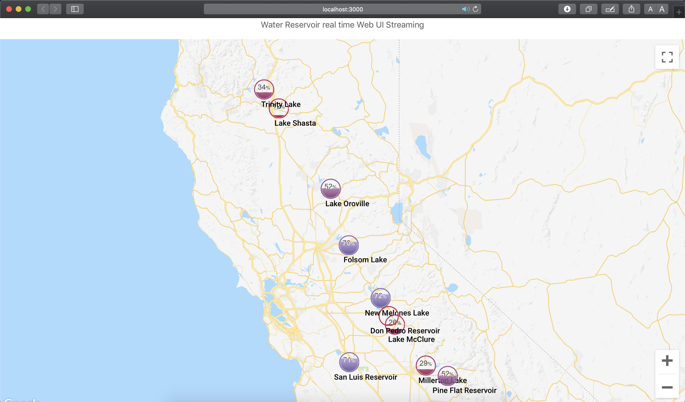

**Screenshot 2:**

Can get detailed level rating by clicking on the water gauge indicator component.

